APPENDIX A: SPRINT DOCUMENTATION TEMPLATE
- Summary data
Team number | 5
Sprint technical lead(s) | Duncan
Sprint start date | 16/02/25
Sprint end date | 22/02/25

- Individual key contributions
Team member | Key contribution(s)
Eric Shi | Created AI flowchart and dice ideas
Lin Hein | Implemented dice roll animation
Owen Chen | Developed UI
Duncan Law | Fixed screen size issues and bug fixes
Stuart Baker | Produced sprint documents and notes

- User stories / task cards
Task 1 will fix an issue we found as we found that when trying to run the full game so far, the playing screen would be a faulty size. Either too large or too small and didn’t provide the user with an option to change the size. Achieving this will improve the user experience and make the game playable in some cases where it was too large to display certain buttons.

Task 2 is an addition to task 1 but focusing more on zooming in and out of the board, rather than the entire display. This will allow the user to better visualise the board and see clearer what tiles contain which properties/cards etc. it isn’t a requirement, but it is a feature we feel will improve the user’s experience.

Task 3 expands on this feature which we have already implemented in the first sprint cycle but will ensure their location is always visible as sometimes it was hidden when we test ran the game. In addition to this, we will change their location marker to their actual game token, rather than a square of colour.

Task 4 likely won’t be as complex as a full-on dice roll animation, as if it was an animated version of when you roll the dice in real life. Rather, it will just show the numbers ‘rolling’ for each dice, until they come to a standstill on the final numbers. This won’t be a long animation, ideally less than two seconds, but will be one that can make the game slightly more interactive and lifelike.

Task 5 is purely a preparatory task for later in the production stage. It will provide us with a good foundation for the mandatory AI player agent, so when it comes to programming it, we will have some basic guidelines and ideas to follow.

Task 6 focuses on making the game “have a colourful and intuitive interface that reflects the spirit and character of the original board game”. Our previous sprint cycle produced a basic board interface, but it lacked colour and creativity which needs to be added to fulfil this domain requirement.

Task 7 completes Mr Raffles request of having two game versions available, which we feel is a major requirement in the development. When loading and starting the game, we will present the players with an option to choose which game version they wish to play, and allow them to choose the time restriction they desire.

Task 8 is a visual effect that will allow the players to see how much time is remaining before the game ends when playing the abridged version. This can also provide them with the ability to play the game more tactically as they can take their turns faster or slower depending on board positions and their current circumstances.

Task 1: Adjust screen size when starting the game
Task 2: Integrate zoom in and zoom out functions
Task 3: Ensure players location is always displayed on the board
Task 4: Create a dice animation based on Eric’s idea
Task 5: Prep AI by making flowchart, deciding on their behaviours
Task 6: Update UI
Task 7: Add the two game mode options; full game and abridged game modes
Task 8: Include a timer into the UI for abridged version

- Requirements analysis

Task 1, 2, 3 and 4 all cover the broad user requirement of “the game should be fun to play”. This is an optional, non-functional requirement that we want to fulfil because it will create a better user environment and experience.
Task 1 and 2 are more for ease of playing for the user as they will be able to play the game on a correct screen size, and zoom in if they are having difficulties seeing the smaller components of the game.
Task 3 focuses on our interpretation of rule 1, where it states, “all players start on the board space labelled GO”. We decided that this meant the players game tokens should be visible and wanted to keep this consistent by making them visible for the entirety of the game.
We hope task 4 will make the game more fun to play because it allows the players to connect to the game more, as they are seeing their dice ‘roll’ in real time, rather than just being given the results. We will also ensure the dice is “fair with each dice having an equal probability of landing on one of its six sides”.

Task 5 requires us to analyse the brief to find how Mr Raffles wants the AI agents to behave. We understand that the AI “does not necessarily need to be good” at the game, so will first ensure we have a working prototype. However, the flowchart will be preparing for after we have a working AI, when we are able to build on this and allow it to have different difficulty levels and behaviours. We should have time to implement this in the future, and having the flowchart ready earlier will save us time in the development stage.

Task 6 addresses the part in the brief which states the game should “have a colourful and intuitive interface that reflects the spirit and character of the original board game”. This is an optional task, but one we wish to achieve as it will only benefit our game and the users experience. We will add colour to the board, and keep it easy to understand for the players, hoping that for them, it will be just like looking at the physical version they may have or used previously.

Task 7 answers “The game can be played in two versions: The full game: ... . The abridged game: …”. This is a mandatory, functional requirement that we will complete, and we feel is integral to the games core, as we understand some players will only want, or be able to, play for a specific amount of time. We will fulfil this by providing the players with a choice before starting the game, a choice of which game version they wish to play, and if they choose the abridged version, a time limit as well.

Task 8 builds on task 7 by including a timer countdown into the abridged version UI, and could also be seen to build on making the game ‘fun to play’ and having a ‘colourful and intuitive interface’, as the game won’t suddenly end without any warning.

- Design

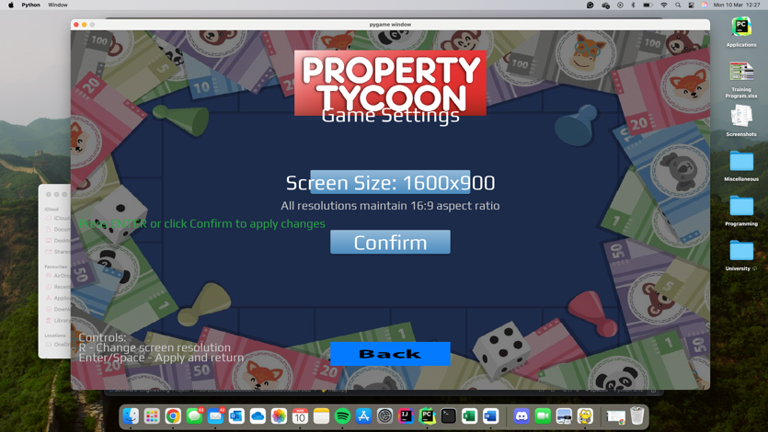
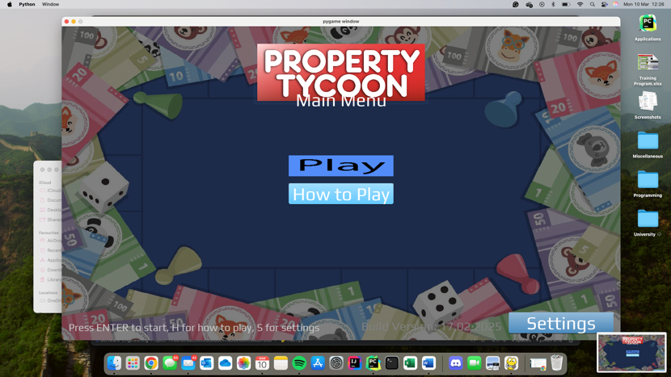
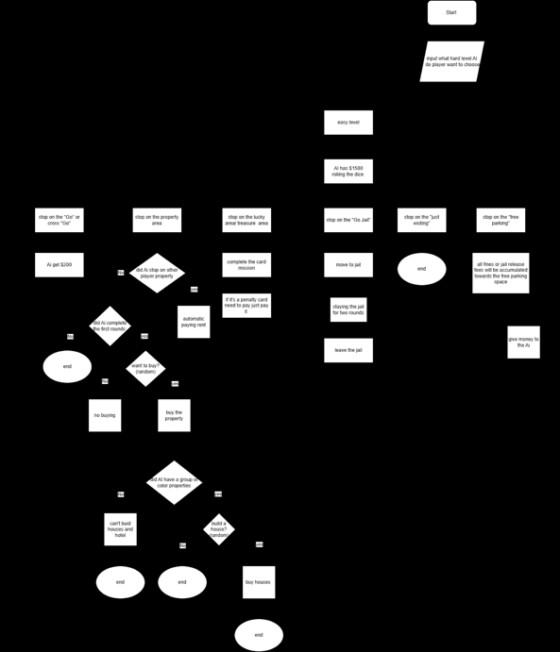
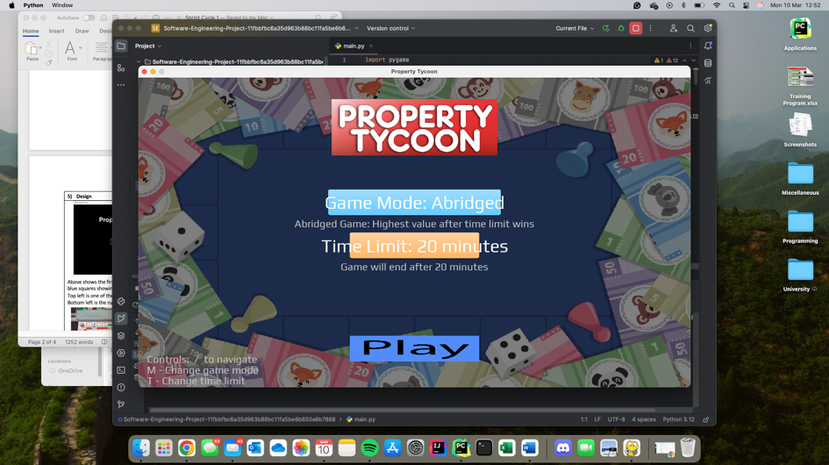
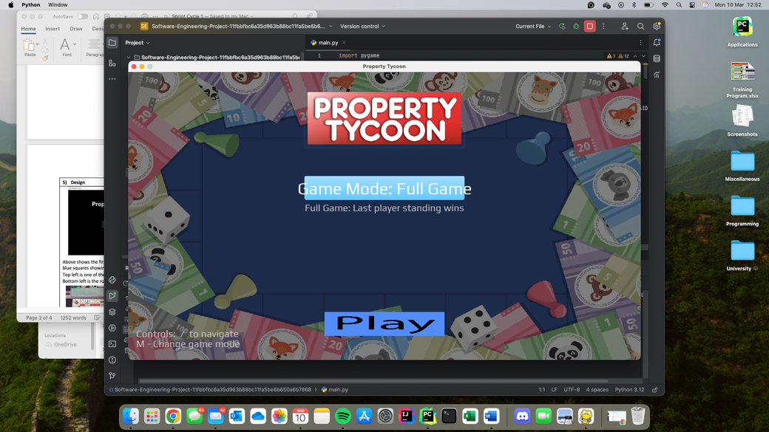

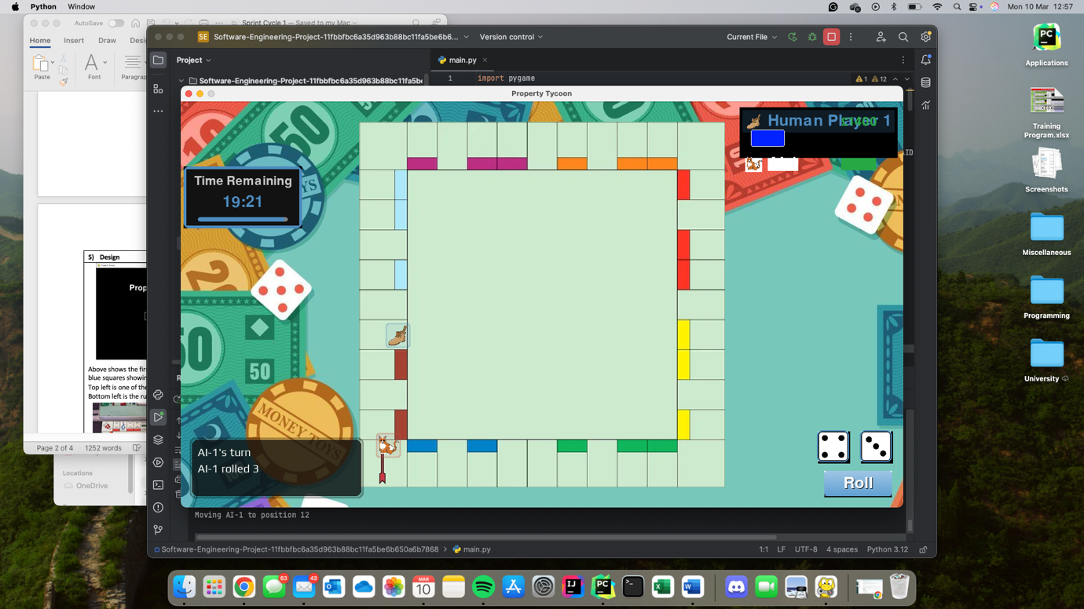

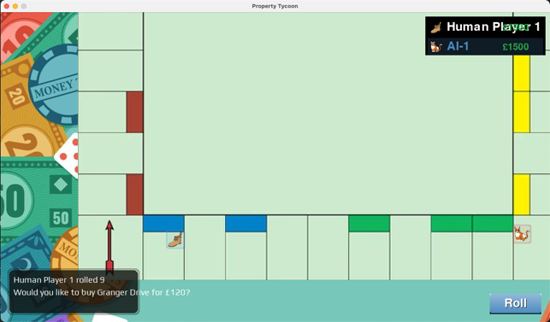
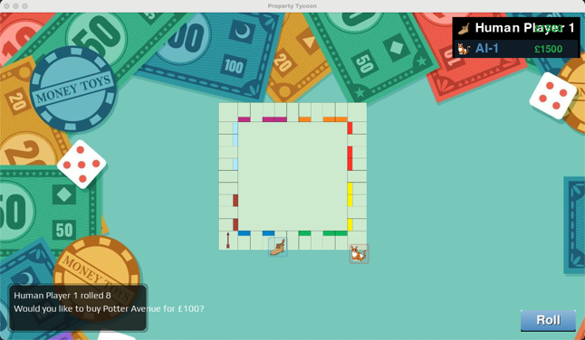
8 images have been included to show the development and results of this sprint.
The flowchart image (top right) is the AI flowchart we designed, specifically for ‘easy’ mode, which will be the AI interpretation we will aim to produce first.

Then, from top left going downwards two images, then right one image, the starting UIs for the game are shown. This shows the home screen, where you can choose your screen resolution by pressing the ‘settings’ button, then selecting your desired screen size, of which there are 4 options currently.
Once you are happy with the screen size, you press confirm, then play, which takes you to another screen not included (for future AI selection), then it takes you to the game version screen. Here, you can select either ‘Full Game’, or ‘Abridged’. If you choose abridged, you can select 3 different time limits, either 10, 20 or 30 minutes.

Upon pressing play, you are loaded into the main games UI, which us the final three images. The top image if the triangle is taken from the ‘abridged’ versions UI, where you can see the timer is included and counting down. This image also showcases the players location on the board, as well as the dice animation mid roll.
The bottom two images display the zoom out and in feature respectively, as well as the players board location. These two images were taken when playing the ‘full game’ mode, but not during a roll, hence why no dice are visibly rolling.

- Test plan and evidence of testing

As this sprint cycle was more bug fixing and making the game more playable, the only testing we did was like in the first sprint cycle. No formal testing was undertaken, only checking that the code would run without throwing any errors, and that visually all our targets were met when running the ‘full’ game code.
We did play the game a few times as a group, checking each user task was met and finding areas to improve upon, but we have no video evidence of this to upload.
Again, formal testing will be added in further down the development process.

- Summary of sprint

Overall, the sprint cycle went well, and we achieved all our objectives, although a few bugs have been thrown up. We understand that some of our user tasks were quite basic, but they will be important for the final submission as they are the foundations our game will be built upon. In future, we expect to have user tasks which are more time consuming and may not go exactly as we planned. However, for this sprint, we are very happy with the results and have gained valuable insights into how we must approach the development going forward.

There is a working prototype, and it is roughly where we expected it to be at this point in time. We have a functioning game that has built on the previous sprint well and incorporates both required game versions. Both versions work all the way to the end of the game.

The whole sprint worked well, from the goals that we set out to achieve, the results of those goals, and the communication throughout the sprint. We found that the updated requirement analysis helped with the user stories and task cards and gave us valuable insights into what we needed to accomplish with each task.
All tasks 1 through 8 were completed with a desirable outcome, but there were certain aspects that weren’t achieved as smoothly or fully as we wished.
- Although task 1 is a major improvement on before, we were unable to provide the players with an option to have a full screen that adapts to the size of the PCs screen. We will consider implementing this in the future.
- Task 2 was achieved, but we found that sometimes the zoom in and out feature works too quickly, so finding your desired zoom percentage can be hard. However, we did expand on this user story and add an extra feature that allows you to move up, down, left and right around the board whilst zoomed in. this is a useful feature but does cause the game to crash if you mistakenly use the arrow keys instead of the ‘WASD’ keys for this.
- We decided on task 5 to only include the ‘easy’ levels flowchart for the moment, as this is the first and main difficulty we wish to produce. In future, we will add more behaviours.
- For task 7, our only improvement we can think of currently is to add more available time limits for the players when they choose the abridged version. We will either do this by adding an extended number of times, most likely being incrementing in increasingly larger time differences (45, 60, 90, 120 minutes etc.), or by allowing the player to choose their own time limit.

We learnt that not everything will go entirely as planned, and unexpected disruptions and bugs will occur. For instance, train cancellations can cause members to miss scheduled team meetings, illness can disrupt the time taken to complete tasks and bugs can be thrown up where you least expect them, such as with pressing the arrow keys causing the game to crash. However, as we had planned for such events and allowed some slack time to let us catch up, the negative effects were kept to a minimum, and the positives were acknowledged. We didn’t let these small negatives lower our morale.
For future sprints, we will try to keep a similar approach to this and the previous sprint as we feel they went very well and produced great results. One main difference is that the next sprint(s) will likely involve heavier user stories and task cards, which may require more time than we previously thought. We will plan for this and have already begun preparations, with the AI flowchart for instance, that will enable us to stay on track.

We currently have no feedback from the customer, but we have been sticking to the design brief and not been skipping or altering mandatory and optional requirements, so we feel it should be to their liking. However, we will aim to get more feedback during the sprints from Mr Raffles and his team, to ensure our development and prototype is as they desire.

